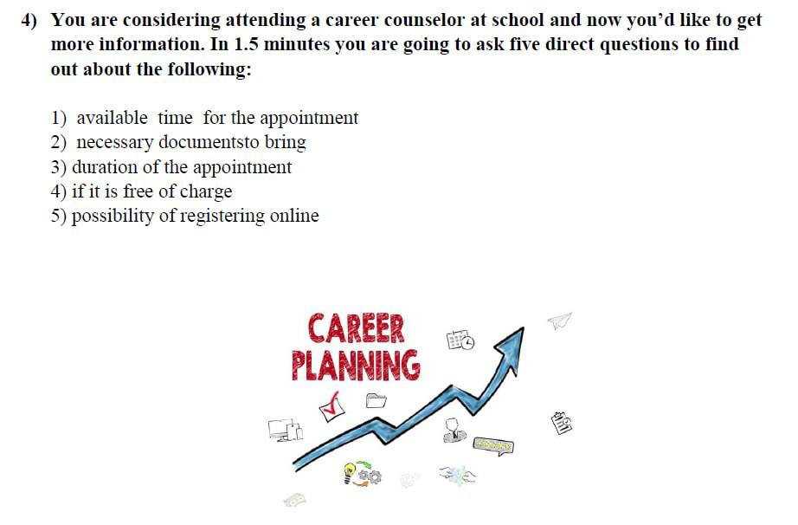What is available time for the appointment? What documents do I need to bring? What is the duration of the appointment? Is the appointment free or charged? You

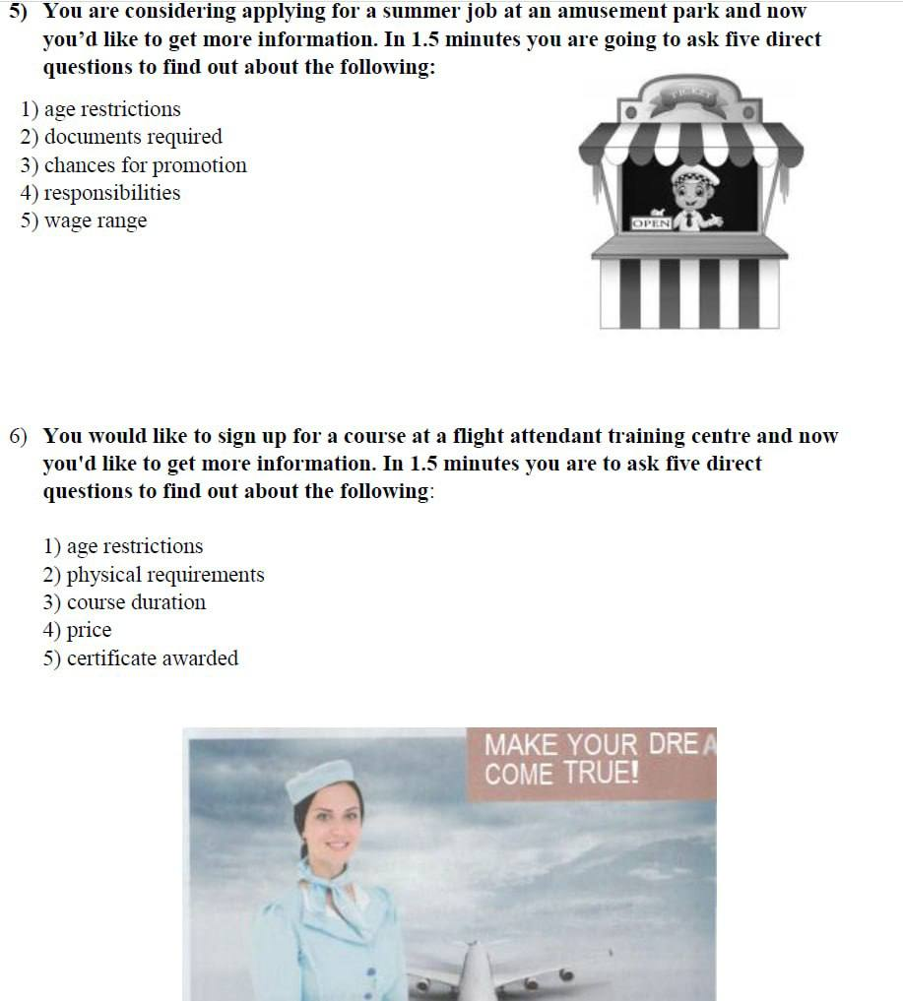
Are there any age restrictions for this job? What documents do I need to provide? What are the chances for promotion? What are the main responsibilities in this job? How much will I pay it?
are there any age restrictions for the course are there any physical requirements what is the duration of this course what is the price of the course Will I wear any certificate after I finished this course?

magine that you are doing a school project “The world of professions”. You have found some photos to illustrate it but for technical reasons you cannot send them now. Leave a voice message to your friend explaining your choice of the photos and sharing some ideas about the project. In 2.5 minutes be ready to:
- explain the choice of the illustrations for the project by briefly describing them and noting the differences;
- mention the advantages (1–2) of the two professions;
- mention the disadvantages (1–2) of the two professions;
- express your opinion on the subject of the project – which of the professions presented in the pictures you would choose and why.
You will speak for not more than 3 minutes (12–15 sentences). You have to talk continuously.


She wears a special uniform and she is in the kitchen. And she is working alone. She is working alone. And the second picture I see a work team. There are three boys and three girls. And I think they're solving some problems. And I think they're solving some problems. As for the advantage for the first picture, I can say that working alone can be boring. As for the advantage for the second picture, as for the advantage for the first picture, I can say that cooking different dishes for the, to improve, to impress the guests, can be very exciting work as for the advantages for the second photo I can say that working in company is very absorbing exciting very absorbing very good to go and you can and broaden your horizons and listen different kinds of opinions. As for the disadvantage, for the first photo I can say that working all day alone can be boring. for the disadvantage for a second photo I can say that the office work all day can be very annoying as for me I will choose kind of I will choose work like I I would choose work that presented in the first picture because I like cooking and I'm an introvert so I like

